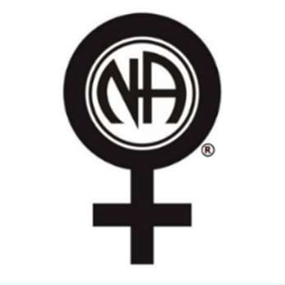
2026 Worthy Women’s NA Retreat Registration
Hosted by the Worthy Women NA Meeting in Moses Lake, WA

July 9th – 12th, 2026

$45 Registration Fee – Includes: Lodging, Meals*, and Activities 343 Kerr Road, Nordman, ID 83848

“Braless & Flawless”

Event Chair: Paige R. Entertainment Chair: Cristel S. Logo
Vice Chair: Pam A. Craft Chair: Trisha R. for Treasurer: Amber B. Meal Chair: Jennifer H. shirts
Registration Chair: River E. Secretary: Kalee H.
Meetings Chair: Jamie M. Clean-up Chair: Winnie S.
Name__________________________________________Phone____________________________________________

Address________________________________________City/State/Zip______________________________________

PRE-SALE MERCHANDISE (List qty and size for each, Sizes S-3XL)
Hoodie ($40 each) _____________ V-Neck T-shirt ($25 each) ______________ Tank Top ($20 each) _______________
TOTAL for Registration ($45) and any additional Pre-Sale Merchandise $__________________
Contact River E. to Register @ 509-750-1681
Registration is limited to 30 women. Scholarships are available.
This is dry camper/trailer or tent camping.
There is a cabin that is limited to the committee members, but bathrooms and showers are available.
If a special accommodation is required for attendance, please notify the registration chair.
Bring a chair as activities and meetings will be held outside.
This is a child and dog-free event.
Please let us know if you are willing to be of service. We will need help with the craft, preparing meals, cleaning up after meals, cleaning up at the end of our stay, etc.
*Meals include: Thursday Dinner, Friday & Saturday Breakfast, Lunch, & Dinner, & Sunday Breakfast
There will be no accommodations for dietary restrictions. Please bring your own food if you have restrictions. REGISTRATION AND PRE-SALE MERCHANDISE CUTOFF DATE: JUNE 4th, 2026
Emergency Contact Information:
Name ________________________________Phone Number ___________________________
Join our Facebook group Page for more information and updates: Worthy Women Retreat 2026

